Student’s Name
Institutional Affiliation
Course Name
Instructor’s Name
Date

Beta-adrenergic Receptors
Introduction
Beta-adrenergic receptors belong to the G protein-coupled receptor family. The receptors are encoded by the ADRB1R gene and the ADRB2 gene for beta 1 and beta 2 receptors respectively. These genes are located on chromosome 10q25.3 in human beings. The receptors are widely known to mediate the actions of the catecholamines, norepinephrine, and epinephrine, which play a vital role in the regulation of myocardial muscle contractility among other important metabolic functions.
The G protein-coupled receptor family comprises of diverse transmembrane receptors found on the cell membranes of eukaryotic organisms. With over one thousand varieties of G protein-coupled receptors, their significance in the body cannot be overemphasized. Belonging to this superfamily are the adrenergic receptors, the beta and alpha receptors. In this paper, the beta-adrenergic receptor will be examined in detail.
Structure
The beta-adrenergic receptor is a single polypeptide transmembrane glycoprotein that is linked to the enzyme adenylate cyclase and the Gs (stimulatory G proteins) forming the beta-adrenergic receptor complex (A De 1990). Three types of beta-AR exist; beta 1, beta 2, and beta 3 receptors (S. Blake 2012). As seen below, the receptor comprises of eight polypeptide helices, seven of which run across the cell membrane while one runs parallel intracellularly. It contains a C terminus, an N terminus, and six loops. Three of these loops are intracellular whilst the rest are extracellular.
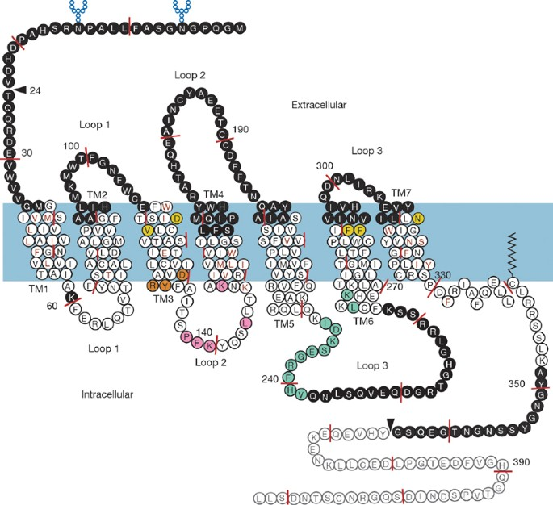
The receptor contains a binding site within its transmembrane component. Linked to the receptor are the Gs; G gamma, G beta, and G alpha. Of these, G alpha is the active site which propagates the signal to the adenylate cyclase in a series of reactions.
The primary binding site (which binds norepinephrine, epinephrine, or drugs) contains 5 residues. The residues interact with the receptor agonist or antagonist through forming hydrogen bonds. These residues accept protons donated by the incoming agonist and consequently a conformational change ensues. The conformational change produces a domino effect and is responsible for activating the Gs. This is the initial step in signal transduction.
Location and Function of Beta-adrenergic Receptors
Beta 1 adrenergic receptors are predominantly located in the cardiac myocytes adipose tissue and the kidneys (Alhayek S 2020). On the heart, activation of the receptor by a sympathomimetic agent increases the electrical firing of the atrioventricular and sinoatrial node which increases myocardial contractility, and as a result heart rate increases. The overall effect is an increase in cardiac output. The agonistic activity of this receptor is important in preparing the body for fight or flight. Additionally, the inhibition of the receptor is the basis of some treatment options for hypertension and cardiomyopathies.
In the kidneys, activation activating beta 1 receptors causes the contraction of the smooth muscles surrounding the juxtaglomerular, thus facilitating the release of renin from the apparatus. Renin serves to increase the volume of blood through a cascade of reactions involving the hormone aldosterone and angiotensin II. An increase in blood volume may exacerbate hypertension if peripheral vascular resistance does not reduce.
In adipose tissue, sympathomimetic action on the beta 1 receptors causes stimulates the breakdown of fat to release energy in the form of ATP. The blockade or downregulation of the beta 1 adrenergic receptor will result in a reverse of the above mention functions.
Beta-2 adrenergic receptors are found in the smooth muscles of the bronchioles of the lung. Upon stimulation by a sympathomimetic agent, the muscles relax causing bronchodilation thereby increasing ventilation. This particular property is applied in the treatment of anaphylaxis by the administration of epinephrine. Beta-2 adrenergic receptors interact with alpha receptors to increase the diameter of the blood vessels in the skeletal muscles; a body mechanism that prepares one for a fight or flight in the face of danger.
The heart also contains beta 2 receptors. However, they are of lower density compared to beta 1 receptors. Stimulation of beta 2 receptors in the heart causes relaxation of the myocardium leading to peripheral hypotension. Paradoxically, this mechanism has a stimulatory effect on the heart, leading to an increase in its contractility reflexively in a bid to compensate for the reduction of the volume of the blood reaching peripheral tissues. Furthermore, beta-2 receptors exist in the uterus where their stimulation inhibits contraction of the myometrium
Beta 3 adrenergic receptors are situated in the urinary bladder, gallbladder, and brown fat. Agonistic activity in beta-3 adrenergic receptors of the urinary bladder causes relaxation of the detrusor muscle hence discouraging voiding. Sympathomimetic action on the receptors of the brown fat results in the generation of heat through the breakdown of fat (thermogenesis). Little is known about the function of beta-3 receptors in the gallbladder. Owing to their action on adipose tissue, beta-3 agonists have been used in weight loss.
Signaling Transduction
Natural catecholamines, adrenaline and noradrenaline, and artificial beta-adrenergic receptor agonists are involved in neurological signaling mediated by these special receptors. In the natural signaling system, the beta-adrenergic receptor agonists are normally released upon the arrival of an action potential, in a series of reactions involving tyrosine, dopamine, and calcium. Norepinephrine binds to postsynaptic receptors on the effector organs, the beta-adrenergic receptors, triggering the desired response. The agonist also binds to presynaptic receptors to stop its further release in a negative feedback response.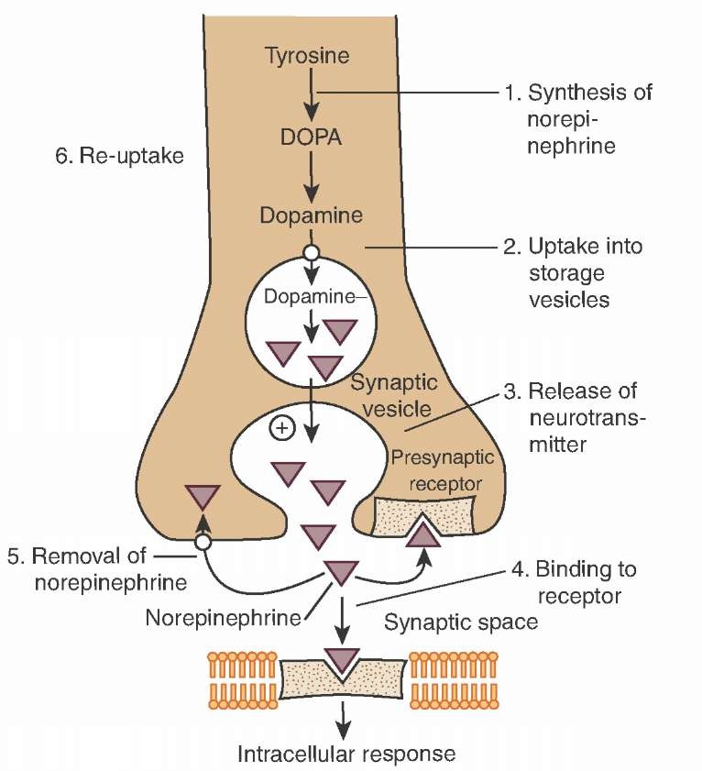
Once the norepinephrine lodges on the beta-adrenergic receptor, the G- protein is activated. The activation causes the release of guanosine triphosphate by G alpha, after phosphorylation of the guanosine diphosphate which is normally present in the inactive state of the receptor complex. The GTP binds to adenylate cyclase. That catalyzes the conversion of adenosine triphosphate to cyclic adenosine monophosphate releasing pyrophosphate as a by-product. The cAMP goes on to activate cAMP-dependent protein kinases. The active protein kinase (protein kinase A in the case of norepinephrine) goes ahead to activate the target proteins in cells such as liver cells and cardiac myocytes. Target proteins include; glycogen synthase which synthesizes glycogen, phosphorylase kinase which phosphorylates glycogen phosphorylase, an enzyme responsible for the catabolism of glycogen to release energy for myocytes. The overall effect is the release of energy for muscular contraction.
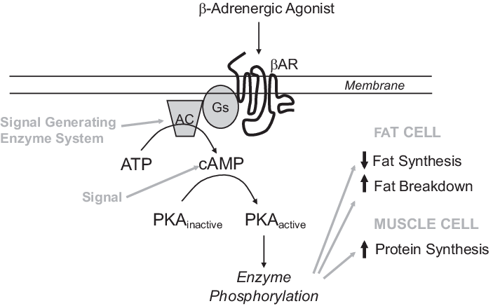
A Study on the Role of Beta-adrenergic Receptors in Heart Failure
Beta-adrenergic receptors play a major role in regulating the heart rate. Their stimulation increases cardiac output in stressful situations; a necessary mechanism to facilitate perfusion in all body organs and tissues to prevent necrosis or organ failure. It is therefore not surprising that dysregulation of these receptors can lead to profound adverse effects on the human body increasing morbidity and mortality of man.
Current research in the functionality of beta-adrenergic receptors is geared towards finding medication for diseases associated with these receptors. One such disease condition is heart failure. Heart failure refers to a condition where the heart is unable to pump enough blood to all tissues to meet the metabolic demands. This condition is prevalent in the developed world majorly due to poor lifestyle and poor cholesterol-laden diet. It is one of the leading causes of morbidity and mortality in the aging population. Beta 1 adrenergic receptors play a significant role in the pathogenesis of heart failure. The underlying pathological process is an increase in sympathetic activity and the downregulation of beta 1 receptors which cause a reduction in myocardial contractility.
Cardiotoxic and Cardioprotective Properties of the Receptors
Recent scientific studies have demonstrated that both beta 1 and beta 2 adrenergic receptors have a part to play in the pathogenesis of cardiomyopathies. Reliable data suggests that agonistic stimulation of beta 1 receptors has toxic effects on the heart while beta 2 stimulation confers protection to the heart thus palliating heart failure (Benrstein D 2011).
In a study by Lefkowitz et alia, in vitro agonistic activity of beta 1 receptors was shown to decrease the density of the receptors, which lead to a decrease in the contractility of myocytes; a salient mechanism in the development of heart failure. Further studies on the hearts of human beings showed a similar downregulation of the beta 1 adrenergic receptors with agonistic activity. Paradoxically upregulation of beta 1 receptors which were few on the hearts of mice proved to be detrimental in the long stretch. At first, cardiac contractility was favorably increased thus registering an increase in the cardiac output. However, as time progressed, myocardial cells underwent fibrosis leading to dilated cardiomyopathy (Ligett S, 2000).
Other studies supported the cardioprotective effect of beta 2 adrenergic receptor stimulation. Agonistic stimulation not only promoted cardiac muscle contractility but also prevented cell apoptosis (Singh K, 1999). Cardiac stimulation is normally mediated by the Gs subunit coupled to the G-protein of the beta 2 adrenergic receptor while apoptotic inhibition occurs through the activation of the Gi subunit linked to the same receptor. However, beta-agonists are primarily used in chronic pulmonary obstructive disorders (COPD).
In the light of these discoveries beta receptor blockers have been invented and are clinically used in treating cardiovascular-related diseases such as hypertension. Their use in heart failure will be evaluated in the following section.
Cardioprotective Effect of Beta-Adrenergic Blockers
For a long time, beta-adrenergic receptor blockers have been contraindicated for use in the treatment of heart failure. Due to their effect of decreasing cardiac contractility, leading to reduced cardiac output, they were thought to decrease cardiac function in the already failing heart. Indiscriminate blockade of sympathomimetic stimulation is potentially hazardous and life-threatening. Bradycardia is the consequence of such blockade and since beta blockers reduce myocardial contractility, heart failure due to cardiomegaly or ischemia will be exacerbated. Furthermore, their bronchoconstriction action impedes ventilation which further worsens heart failure and underlying conditions such as COPD. However, selective beta 1 AR blockers such as atenolol and nebivolol have been suggested to protect the heart apart from mitigating hypertension, their primary function. Active research has been going on in recent years to weigh the benefits against the disadvantages of using beta-blockers in heart failure patients.
In a research conducted by Packer and others, 1094 patients were enrolled in a study where the effect of carvedilol a non-selective beta-blocker on morbidity and mortality was investigated. The patients were suffering from chronic heart failure. 398 patients received a placebo while 696 were given carvedilol in the appropriate doses. Both groups received a background regimen of digoxin and an angiotensin-converting enzyme inhibitor. Results demonstrated a reduction in mortality rate. Only 3.2 % of the patients who used carvedilol had succumbed compared to 7.8 % of the patients who were on the placebo.
In another study on the effect of metoprolol, a selective beta 1 adrenergic receptor blocker, on mortality rate, 383 patients with idiopathic dilated cardiomyopathy were enrolled in a study (Barrese V, 2013). A blind study involving metoprolol and a placebo was done. At the end of the study, metoprolol treated patients registered a positive change in ejection fraction and a reduction in pulmonary capillary resistance. Moreover, the patients were able to exercise for a longer time compared to the patients who were under the placebo (Waagstein F, 1993). Both groups of patients received background treatment. Thus metoprolol was shown to provide symptomatic improvement and reduce the risk of death due to the existing cardiac condition.
In a similar study, the benefit of bisoprolol, a beta 1 selective adrenergic receptor blocker was analyzed in patients suffering from dilated cardiomyopathy (Wilenheimer R, 2005). A double-blind study involving a placebo and bisoprolol was conducted on patients with less than 40% ejection fraction. A background therapy of ACE inhibitor with a diuretic was also provided. Follow up studies on the patients done 1 year and 9 months later showed no significant reduction in mortality rate in bisoprolol treated patients compared to the placebo-treated patients. However, the patients reported to have lesser symptoms and were able to carry out daily activities with ease.
In yet another study conducted by Poole-Wilson and others, the effect of carvedilol and metoprolol on mortality was investigated. The study aimed to compare which medication was safer and better at reducing the overall mortality of patients living with chronic heart failure. A randomized, double-blind study involved 1511 patients on carvedilol and 1518 patients on metoprolol. After four years and ten months, thirty-four percent of the patients on carvedilol had died while forty percent of the patients on metoprolol had passed away. The results suggested that carvedilol was better than metoprolol at extending the life span of patients suffering from heart failure.
Characterization of the Beta-Adrenergic Receptors
As aforementioned in this paper, the agonistic and antagonistic activity on beta-adrenergic receptors has different effects on the heart that can either be desirable or life-threatening. Therefore, characterization of these receptors is paramount as it guides drug synthesis and therapy of heart-related diseases. The characteristics of receptors include; receptor upregulation and downregulation with regards to external factors (such as drugs and ionic concentration), their ability to transduce signals irrespective of the nature of the ligand so long as appropriate binding between the ligand and the receptor occurs and change in the density of receptors in various organs as a result of physiological or physical activities. This experiment will focus on the effect of adrenoceptors and electrolytes on the density of receptors in the myocardium.
To determine the effect of drugs such as propranolol on receptor density, a controlled biochemical study needs to be conducted. Human trials on experiments involving the heart may be hard due to ethical issues, however, animal studies would be possible and the myocardium of mice could be used in this experiment. To quantify the density of receptors, the interactions of a ligand and the receptors have to be examined through radio isotopy.
The first important step is to acquire the myocardial tissue of the rat. Afterward homogenization of the organ is carried out. The next step involves obtaining a radiolabeled drug or antigen which can bind to the beta-adrenergic receptors. The homogenized organ should then be incubated with the ligand. After incubating the ligand which is unbound should then be separated from the ligands which have been bound and the interaction of the latter should be measured based on its radioactivity.
Alternatively, human lymphocytes may be used as they also have beta-adrenergic receptors. In a similar process, as with the myocardial tissue, the effect of different drugs on the density of beta-adrenergic receptors can be examined. To investigate that, a control experiment should be done on the subject, where no drug has been used. The radioactivity of the bound radiolabeled ligand should be measured and recorded. Afterward, the subject should be put on a suitable beta-adrenergic receptor blocker for four weeks or a period when a significant response is expected to have occurred. Then the experiment should be carried out again to determine the radioactivity similarly. The results should then be compared to gauge the effect of the drug on the receptors. Similar studies can be carried out with electrolytes which contain various ions such as sodium. However, all these studies should be conducted with the aim of treating the underlying disease and with appropriate consent.
These studies will have immense utility in treatment as the density of receptors on an organ is important in determining the amount and quality of response. Any drug which is to be used to treat heart conditions can be subjected to this experiment as a way of determining its efficacy. Drugs that can cause erratic upregulation of beta-adrenergic receptors ought to be avoided as they may lead to arrhythmias while drugs that lead to downregulation of receptors may worsen existing heart failure.
Conclusion
The discovery of beta-adrenergic receptors and their roles in disease pathology provided an opportunity to develop therapies that can reduce morbidity and mortality in people suffering from various diseases involving these receptors. Notable diseases due to dysregulation of beta-adrenergic receptors are those that involve the cardiovascular system such as heart failure and the respiratory system such as COPD. Medicines that block the interaction of these receptors with catecholamines play an important role in the treatment of hypertension (selective and non-selective beta-blockers). However, indiscriminate blockade of beta-adrenoceptors has been shown to have overall negative effects on the human body. Further research on the benefit of beta-blockers and agonists ought to be done to determine the drugs that can be used with minimum side effects to improve the quality of life of the patients with these lifelong conditions.

References
A, D. (1990) "Beta-adrenergic receptors: structure, function and regulation", Drugs under experimental and clinical research, 16(3), p. Available at https://pubmed.ncbi.nlm.nih.gov/1974837/#:~:text=The%20beta%2DAR%20is%20a,form%20the%20beta%2DAR%20complex.&text=The%20beta2%2DAR%20protein%20is,of%20seven%20membrane%20spanning%20regions. (Accessed: 22 November 2020).
Alhayek, S. and Preuss, C. (2020) "Beta 1 Receptors", StatPearls Publishing, p. Available at https://www.ncbi.nlm.nih.gov/books/NBK532904/#:~:text=Beta%2D1%20receptors%20are%20predominantly,through%20the%20Gs%20alpha%20subunit.&text=In%20the%20kidney%2C%20smooth%20muscle,apparatus%20contract%20and%20release%20renin. (Accessed: 22 November 2020).
Bernstein, D., Fajardo, G., and Zhao, M. (2011) "The role of β-adrenergic receptors in heart failure: Differential regulation of cardiotoxicity and cardioprotection", Progress in Pediatric Cardiology, 31(1), pp. 35-38. DOI: 10.1016/j.ppedcard.2010.11.007.
Liggett S, Tepe N, Lorenz J, Canning A, Jantz T, Mitarai S, et al. Early and delayed consequences of β2-adrenergic receptor overexpression in mouse hearts. Critical role for expression level. Circulation. 2000;101:1707–14
Communal C, Singh K, Sawyer DB, Colucci WS. Opposing effects of beta(1)- and beta(2)-adrenergic receptors on cardiac myocyte apoptosis: role of a pertussis toxin-sensitive G protein. Circulation.
Packer, M. et al. (1996) "The Effect of Carvedilol on Morbidity and Mortality in Patients with Chronic Heart Failure", New England Journal of Medicine, 334(21), pp. 1349-1355. DOI: 10.1056/nejm199605233342101.
Barrese, V. and Taglialatela, M. (2013) "New advances in beta-blocker therapy in heart failure", Frontiers in Physiology, 4. doi: 10.3389/fphys.2013.00323.
Waagstein, F. et al. (1993) "Beneficial effects of metoprolol in idiopathic dilated cardiomyopathy", The Lancet, 342(8885), pp. 1441-1446. DOI: 10.1016/0140-6736(93)92930-r.
Willenheimer, R. et al. (2005) "Effect on Survival and Hospitalization of Initiating Treatment for Chronic Heart Failure With Bisoprolol Followed by Enalapril, as Compared With the Opposite Sequence", Circulation, 112(16), pp. 2426-2435. DOI: 10.1161/circulationaha.105.582320.

